**Curriculum overview in Y3 for spring 2 half term**

**Religious education**

Our topic for RE is a call to change and reconciliation.’ Within this topic we will be looking at what the sacrament is and the meaning behind it.

**Topic- History**

In History this half term we will be learning all about the Romans. We will be learning all about their army, invasions, why they wanted to come to Britain and what they left behind. We will also be looking at Boudicca and the role she played.

**English**

Our text for the first half term is ‘The Ion Man’ by Ted Hughes, we will be using the text to help us to write setting and character descriptions. We will then be moving on to a non-chronological report, working on a non-fiction piece of writing.

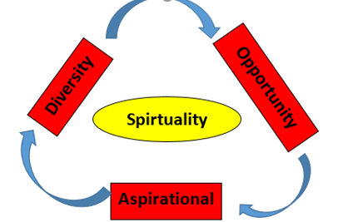

**Science**

This half term we will be learning all about plants. The names and functions of each part, seed dispersal and photosynthesis.

**Computing**

We will be focusing on creating media and desktop publishing

**Music**

This term we are continuing with Music tuition from Norfolk Music Hub and the children will be developing more skills in musical instruments and music knowledge.

**PSHE**

We will be learning about emotional wellbeing this half term, focusing on positive friendships.

**Art**

We will be looking at the topic of collage. We will be looking at lots of different artists throughout this topic such as Paul Klee.

**PE**

We will be focusing on tag rugby on a Thursday and swimming on a friday

**Maths**

In Maths, we are continuing with length and measurement and then we will be moving on to fractions. We are still working our times tables, especially our 3’s, 4’ and 8’s.

